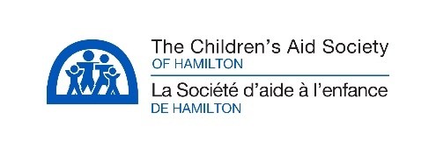
DONATION FORM

Donor Information

Name:
Address:
City, Province: |  |  | Postal Code:
Phone: |  |  | Email:

General Donation

I would like to make a donation in the amount of |  |  |  | $ to:
 | Bursaries |  | Children’s Fund |  |  | Holiday Programs
 | Market 26 |  | Summer Camp |  |  | Volunteer Programs

In Memory/Tribute Gift

I would like to make a donation in the amount of |  |  |  | $
 | In Memory of:
 | Tribute (Birthday, Teacher’s Gift, Anniversary, etc) to:
Please direct this gift to: (Funds listed under General Donation)

Acknowledgement to: (Please provide the name and address of person(s) to be advised of your gift)

Payment Details

Cheque (Payable to The Children’s Aid Society of Hamilton) |  | Tax receipt required Yes No
Visa | MasterCard |  |  | AMEX
Name on Card:
Card Number: |  |  | Expiry:

Please return the completed form and payment to:

Communications & Development Unit, The Children’s Aid Society of Hamilton
PO Box 1170, Depot 1, Hamilton ON L8N 4B9
Fax: 905-572-9733
sbirett@hamiltoncas.com

YES, I would like to receive email correspondence from The Children’s Aid Society of Hamilton.

